6 Practice

There are various methods for studying field heterogeneity that should be applied depending on the specific conditions.

Analysis of soil samples on a grid.

Using this method, the field is divided into cells, from each of which soil samples are taken. Each sample is analyzed separately for humus content, essential nutrients, acidity, etc.
Then, using geostatistical methods, maps of soil properties are created. These maps are used to create recommendations for fertilization for the field-averaged planned yield (i.e., more is applied to areas with low NPKS concentration and vice versa).
In recent years, this approach has been promoted in Eastern Europe as one of the most advanced technologies. I'm afraid to disappoint the adherents of this method, but it is the most expensive in precision farming, the most laborious, the most inaccurate and the most archaic. According to Professor R. Kosla from the University of Colorado (USA), to obtain a real picture of the diversity of soil fertility, it is necessary to take a lot of samples. But to make this method cost-effective, you have to significantly reduce the number. Companies offering mesh sampling in the Russian market offer mesh from 5 to 20 ha, i.e. 225-900 times less than required by the strict rules of science. In such cases, farming ceases to be "precise".
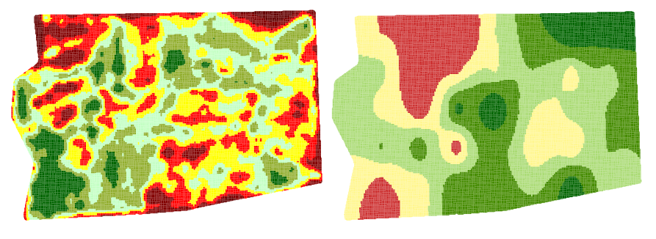
Figure: 4. Comparative analysis of the potential yield within the field and the content of mobile phosphorus in the soil. Green indicates areas with higher yield potential (left) and higher available phosphorus content (right)

If we compare two maps, one of which, created from the analysis of satellite imagery, shows the yield potential in different parts of the field, and the second - the content of the main nutrients, made according to the results of a grid analysis of 5 hectares (Fig. 4., the total area of ​​the field - 200 hectares), then we will see that the five-hectare grid does not provide full detailing of all the features of the field inhomogeneity.
The method has several more disadvantages. Despite the fact that we get a certain picture of the distribution of nutrients in the soil within the field, based on the results of grid sampling, we cannot judge the removal of nutrients from the soil and the potential yield. The fact is that to obtain a unit of production, plants need a certain amount of nitrogen, phosphorus, potassium and other elements. However, this does not mean that as soon as we add all these elements to the soil in large quantities, we will get a yield of 10 t / ha. Yields are influenced by many environmental factors that cannot be determined with simple gridded analysis. In our practice, very often we have to deal with a situation where the content of NPK in the soil was sufficient to obtain a record grain yield, but for various reasons (lack of moisture, soil compaction, high acidity, salinity, etc.), the plants could not use these elements.
Planning fertilizer doses based on one soil analysis, without reference to the real need of plants, is comparable to performing a surgical operation without an X-ray or computed tomography, when a surgeon must manually, by trial and error, determine which organ is affected in a patient, and what exactly is needed operate. It would never occur to anyone to take a tissue analysis from a patient at every square centimeter to localize the zone of a diseased organ, because there are much more effective diagnostic methods. By analogy, however, grid analysis of samples is just such an ineffective method of identifying a problem and finding solutions. As in medicine, in agriculture there are methods of spatial diagnostics of fields, that is, tools that make soil analysis orders of magnitude more accurate and efficient.
Yield Monitor Data Analysis

All the problems described above have long been known, and to solve them, they began to study the natural heterogeneity of the development of cultures within each field. In the mid-90s of the last century, yield monitors appeared - devices that record yield data during harvesting in real time. Subsequently, this data can be viewed and analyzed using a computer. The emergence of yield monitors gave a sharp impetus to the development of precision farming technologies, as the speed of information collection and the accuracy of analysis increased by orders of magnitude.

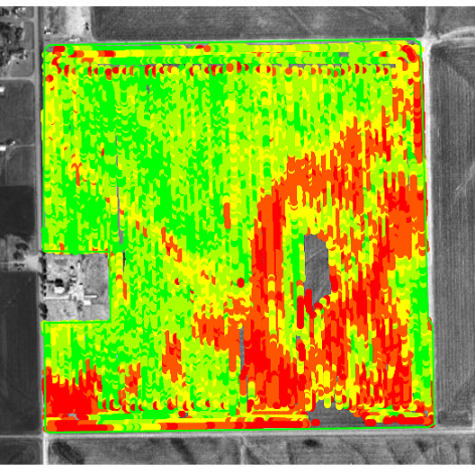
Figure: 5. Yield map (data from SST Development Group).

The benefits of yield mapping are:
• Possibility of accurate determination of the diversity of vegetation development within the field and a significant reduction in the cost of analyzing the heterogeneity of fields in comparison with the selection of soil samples on a grid;
• When properly calibrated, the yield monitor immediately gives absolute yield data, ie. t / ha;
• High geographic accuracy and detailed mapping;
• Ability to create precise field boundaries and define areas in seconds without going around the perimeter.
The method, however, is not without its drawbacks:
• Lack of information on soil conditions;
• The need for additional investment in the purchase of monitors;
• Difficulty collecting data on large farms;
• Large file size;
• The need for accurate calibration of each monitor, especially when operating several combines in one field.
Analysis of aerial and satellite imagery
The science of obtaining information about the earth's surface using satellite images, as well as analyzing such data, is called remote sensing. This is done through the analysis of the spectrum reflected from the earth's surface. Precision farming technology is one of the most successful remote sensing applications in agriculture.
In fact, these methods provide the same information as yield monitoring, but in terms of productivity they surpass it by several orders of magnitude. Currently, none of the existing methods in precision farming can match the productivity and quality of the collected information with satellite imagery. For example, an agronomist may superficially survey several fields of several hundred hectares per day. This analysis will be limited to only those areas of these fields that the agronomist visited. Just one satellite image with a resolution of 1-2 m can provide information on 15-20,000 hectares. When using shooting with a resolution of 20-30 m, one shot can cover up to 160,000 square meters. km of the earth's surface, or 16 million hectares, which exceeds the area of ​​some regions and even the size of small states.
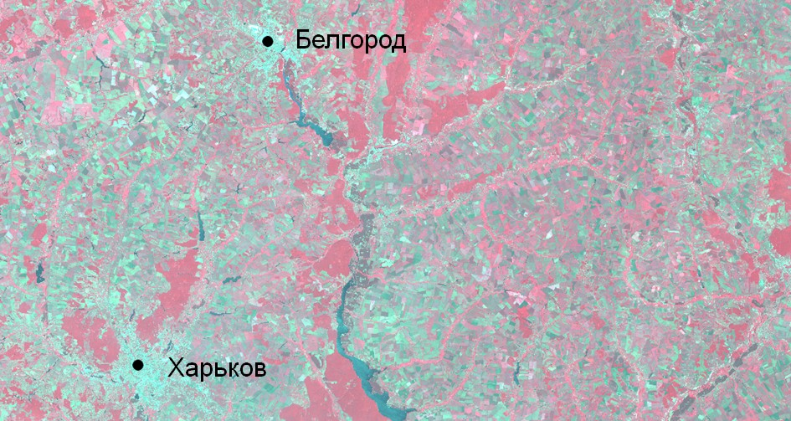
Figure: 6. Fragment of a satellite image of a section of the earth's surface.

Remote sensing methods in precision agriculture are effective over large areas (Brazil, Canada, Russia, USA). They are tens and hundreds of times more productive than monitoring yields and easily eliminate data collection problems on large farms associated with a large number of working combines.
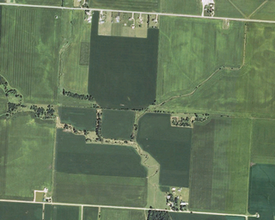
Figure: 7. Aerial photograph of a section of the earth's surface (survey resolution - 0.6 m).

Analysis of archived satellite imagery allows you to see the history of fields over tens of years, as well as compare several images taken during one growing season, which is not feasible when monitoring yield. Satellite imagery can be used for spot application of plant protection products and crop feeding during the growing season.
What can be determined from satellite images? Satellite imagery can provide the following information:
• Spatial relative distribution of green biomass (ie more in one place, less in another). In order to know exactly how many (tons, kilograms) - you will need to analyze samples in the field;
• General assessment of the state of crops (there is stress - no stress);
• Relative water content in green biomass. In order to know exactly how much, taking samples is required;
• The relative content of organic matter in the soil. In order to know how much, you need to analyze samples in the field.
Vegetation indices are used to turn satellite monitoring data into a readable form. There are several dozen such indexes; NDVI (normalize difference vegetation index) is one of the most well known used in remote sensing to analyze vegetation on the earth's surface. It is based on a combination of plant physics and physiology. The reason we see plants as green is that they absorb the blue and especially the red parts of the visible light spectrum. The green part of the spectrum is reflected. If we could also see the infrared part of the spectrum, then plants would look infrared - they reflect almost all infrared radiation. If you compare the different zones within the field for absorption of red light and reflection of infrared, you get a very accurate picture of the distribution of green biomass. There is currently no more accurate method for making such an assessment.
We have also introduced the fertility index into practice. It is a scale by which the potential productivity of zones within a field is assessed. The fertility index has no units of measurement and is expressed as a percentage of the average yield within the field. The calculation of this index is based on the use of various data, including the history of the field, the distribution of biomass over its surface, soil properties, relief, etc.
The use of the fertility index is a unique feature of our technology, in contrast to simplified approaches based on soil analysis on a grid, annual satellite imagery data, or yield monitoring.
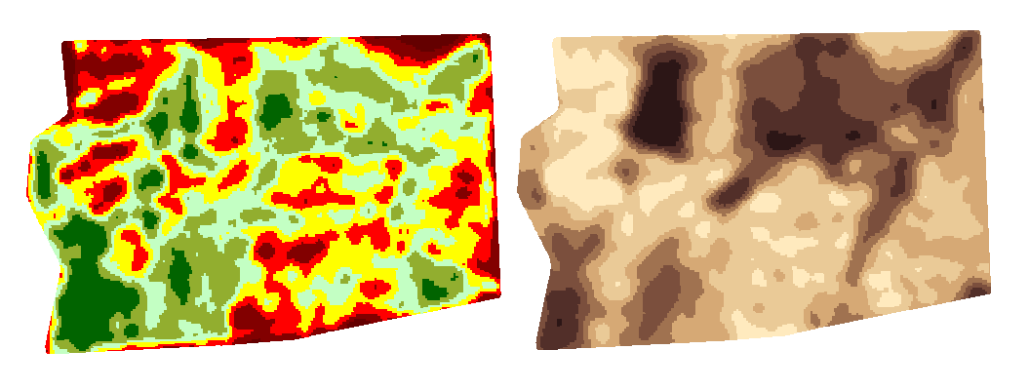
Figure: 8. Comparative analysis of the potential yield within the field and the content of humus in the soil. Green indicates areas with higher yield potential (left), brown areas with higher humus content (right).

Figure: 8. shows the possibilities of satellite imagery for mapping fields on the potential yield in its various areas or the relative humus content. In this case, the dependence is clearly traced: zones with a high organic content in the soil, as a rule, have a higher yield potential. At the same time, these maps do not copy each other, since the increased humus content does not necessarily imply a directly proportional increase in yield.
